I have created an example schedule.
I have come up with some ideas on what to do at home. I have also added some visuals. These pictures are some google.

If you would like me to create a schedule for your student at home, please let me know. I am happy to create a schedule that fits your students’ needs.
Wake up/ breakfast | Have your student help make breakfast! Great practice with following directions and using communication in a different setting.
Sensory time! | Have student explore with a variety of textures.  (shaving cream, water, flour, pasta, soapy water)  For extra fun: put manipulatives (measuring tools, toys, spoons, cups)
Sensory break | Time to calm down before learning time! Practice having your student request what they might need to calm their body. (squeeze, sit down, water) | 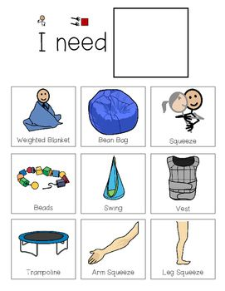
Learning time | Use the resources I have provided via my website to help during this learning time.  This could be exploration with different materials, an art project time, writing, or counting. | 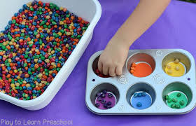
Play time! | This time is so much fun!!  Allow your student to have some creative fun play time!  If you have time, it would be fun to create a dramatic play scene. (some examples: bakery, vet clinic, restaurant) | 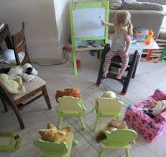
Reading time | You can practice taking turns with your student and each choose a book to read.  If your student has a favorite book, have them try and re-tell you the story. (you can give them cues based on the pictures)  (Miss Joobee’s favorite book is the kissing hand. )
Free time. | This time is for you as a parent to decide what is best for your student.  You may want to work on some more learning time, you may want to let them play, or give them a break time.
Meal time/ bed time | Have your student help you in the kitchen again!  Always fun to have more time exploring.

